**Project Title**

Bookmyshow (Online movie ticket booking application)

**Description**

Main objective of our project is to provide service to customers for booking cinema tickets from anywhere anytime and providing information about the movies and their schedule online.Users can easily search for the movies and available seats without login and after login they can book their tickets online. In this application there are 3 types of user: Admin, Theatre admin and User mode. BookMyShow offers showtimes, movie tickets, reviews, trailers, concert tickets

Figure Membership Module

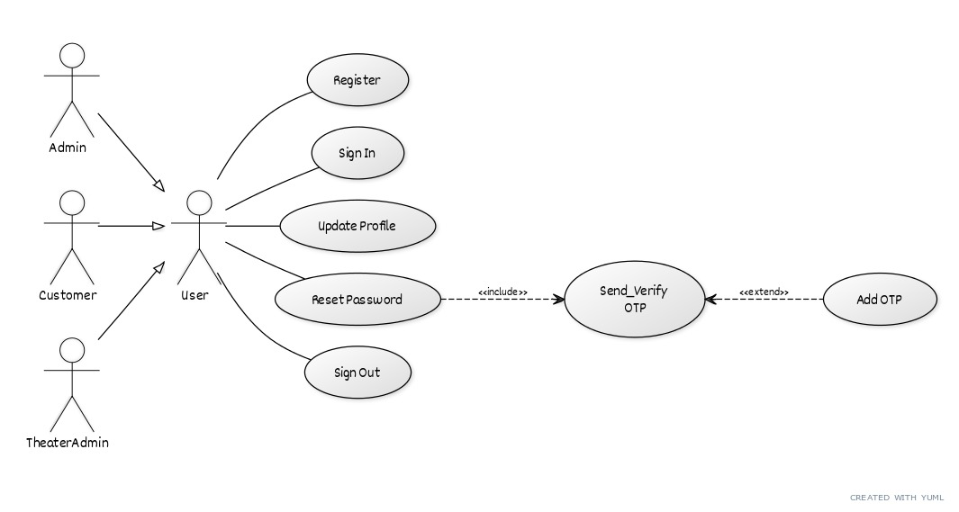

Figure Admin Functionalities

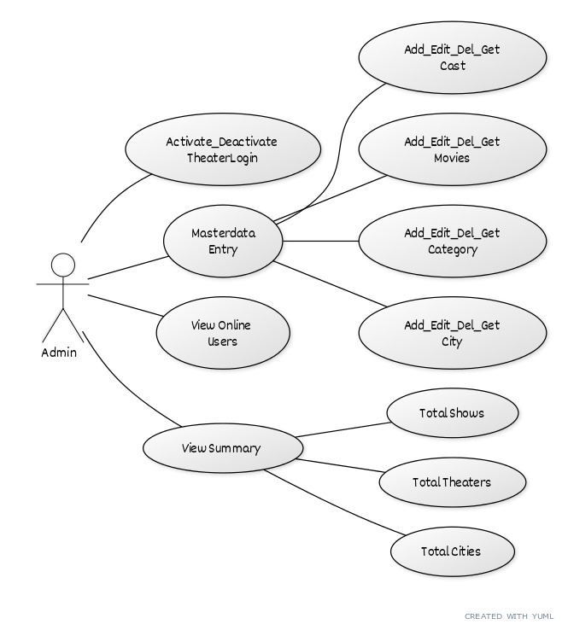

Figure Theater Admin Functionalities

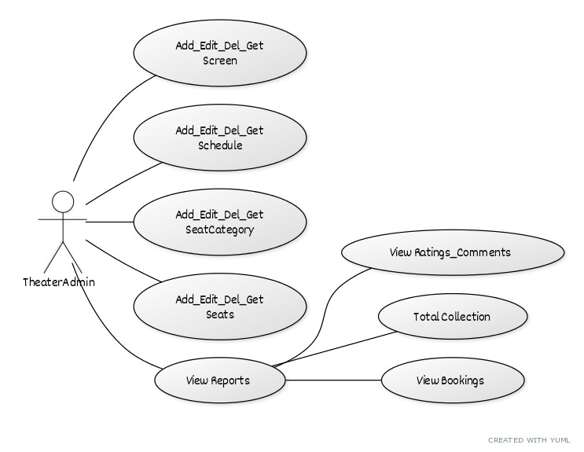

Figure Customer Functionality

